11.Sine wave Generation using ESP 32(Skilling)

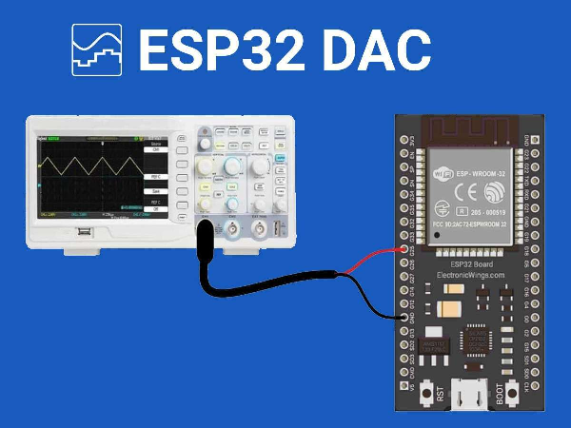

Code:

// Define DAC pins
#define DAC_CH1 25
#define DAC_CH2 26

void setup() {
// Nothing here!
}

void loop() {

// Generate a Sine Wave
// Step one degree at a time
for (int deg = 0; deg < 360; deg = deg + 1) {
// Calculate sine and write to DAC
dacWrite(DAC_CH1, int(128 + 64 * sin(deg * PI / 180)));
}
}

Output:
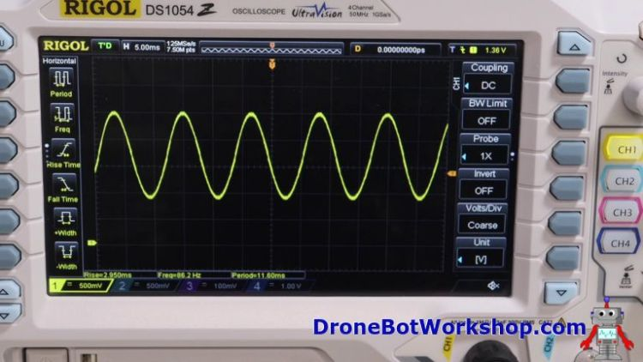
Alternate code:
11.Sine wave Generation using ESP 32(Skilling)

#define Num_Samples 112 // number of dample of signal
#define MaxWaveTypes 4 // types of wave (signal)
int i = 0;

static byte WaveFormTable[MaxWaveTypes][Num_Samples] = {
// Sin wave
{
0x80, 0x83, 0x87, 0x8A, 0x8E, 0x91, 0x95, 0x98, 0x9B, 0x9E, 0xA2, 0xA5, 0xA7, 0xAA, 0xAD, 0xAF,
0xB2, 0xB4, 0xB6, 0xB8, 0xB9, 0xBB, 0xBC, 0xBD, 0xBE, 0xBF, 0xBF, 0xBF, 0xC0, 0xBF, 0xBF, 0xBF,
0xBE, 0xBD, 0xBC, 0xBB, 0xB9, 0xB8, 0xB6, 0xB4, 0xB2, 0xAF, 0xAD, 0xAA, 0xA7, 0xA5, 0xA2, 0x9E,
0x9B, 0x98, 0x95, 0x91, 0x8E, 0x8A, 0x87, 0x83, 0x80, 0x7C, 0x78, 0x75, 0x71, 0x6E, 0x6A, 0x67,
0x64, 0x61, 0x5D, 0x5A, 0x58, 0x55, 0x52, 0x50, 0x4D, 0x4B, 0x49, 0x47, 0x46, 0x44, 0x43, 0x42,
0x41, 0x40, 0x40, 0x40, 0x40, 0x40, 0x40, 0x40, 0x41, 0x42, 0x43, 0x44, 0x46, 0x47, 0x49, 0x4B,
0x4D, 0x50, 0x52, 0x55, 0x58, 0x5A, 0x5D, 0x61, 0x64, 0x67, 0x6A, 0x6E, 0x71, 0x75, 0x78, 0x7C
},
// Triangular wave table
{
0x80, 0x84, 0x89, 0x8D, 0x92, 0x96, 0x9B, 0x9F, 0xA4, 0xA8, 0xAD, 0xB2, 0xB6, 0xBB, 0xBF, 0xC4,
0xC8, 0xCD, 0xD1, 0xD6, 0xDB, 0xDF, 0xE4, 0xE8, 0xED, 0xF1, 0xF6, 0xFA, 0xFF, 0xFA, 0xF6, 0xF1,
0xED, 0xE8, 0xE4, 0xDF, 0xDB, 0xD6, 0xD1, 0xCD, 0xC8, 0xC4, 0xBF, 0xBB, 0xB6, 0xB2, 0xAD, 0xA8,
0xA4, 0x9F, 0x9B, 0x96, 0x92, 0x8D, 0x89, 0x84, 0x7F, 0x7B, 0x76, 0x72, 0x6D, 0x69, 0x64, 0x60,
0x5B, 0x57, 0x52, 0x4D, 0x49, 0x44, 0x40, 0x3B, 0x37, 0x32, 0x2E, 0x29, 0x24, 0x20, 0x1B, 0x17,
0x12, 0x0E, 0x09, 0x05, 0x00, 0x05, 0x09, 0x0E, 0x12, 0x17, 0x1B, 0x20, 0x24, 0x29, 0x2E, 0x32,
0x37, 0x3B, 0x40, 0x44, 0x49, 0x4D, 0x52, 0x57, 0x5B, 0x60, 0x64, 0x69, 0x6D, 0x72, 0x76, 0x7B
},

// Sawtooth wave table
{
0x00, 0x02, 0x04, 0x06, 0x09, 0x0B, 0x0D, 0x10, 0x12, 0x14, 0x16, 0x19, 0x1B, 0x1D, 0x20, 0x22,
0x24, 0x27, 0x29, 0x2B, 0x2D, 0x30, 0x32, 0x34, 0x37, 0x39, 0x3B, 0x3E, 0x40, 0x42, 0x44, 0x47,
0x49, 0x4B, 0x4E, 0x50, 0x52, 0x54, 0x57, 0x59, 0x5B, 0x5E, 0x60, 0x62, 0x65, 0x67, 0x69, 0x6B,
0x6E, 0x70, 0x72, 0x75, 0x77, 0x79, 0x7C, 0x7E, 0x80, 0x82, 0x85, 0x87, 0x89, 0x8C, 0x8E, 0x90,
0x93, 0x95, 0x97, 0x99, 0x9C, 0x9E, 0xA0, 0xA3, 0xA5, 0xA7, 0xA9, 0xAC, 0xAE, 0xB0, 0xB3, 0xB5,
0xB7, 0xBA, 0xBC, 0xBE, 0xC0, 0xC3, 0xC5, 0xC7, 0xCA, 0xCC, 0xCE, 0xD1, 0xD3, 0xD5, 0xD7, 0xDA,
0xDC, 0xDE, 0xE1, 0xE3, 0xE5, 0xE8, 0xEA, 0xEC, 0xEE, 0xF1, 0xF3, 0xF5, 0xF8, 0xFA, 0xFC, 0xFE
},
// Square wave table
{
0xff, 0xff, 0xff, 0xff, 0xff, 0xff, 0xff, 0xff, 0xff, 0xff, 0xff, 0xff, 0xff, 0xff, 0xff, 0xff,
0xff, 0xff, 0xff, 0xff, 0xff, 0xff, 0xff, 0xff, 0xff, 0xff, 0xff, 0xff, 0xff, 0xff, 0xff, 0xff,
0xff, 0xff, 0xff, 0xff, 0xff, 0xff, 0xff, 0xff, 0xff, 0xff, 0xff, 0xff, 0xff, 0xff, 0xff, 0xff,
0xff, 0xff, 0xff, 0xff, 0xff, 0xff, 0xff, 0xff, 0x00, 0x00, 0x00, 0x00, 0x00, 0x00, 0x00, 0x00,
0x00, 0x00, 0x00, 0x00, 0x00, 0x00, 0x00, 0x00, 0x00, 0x00, 0x00, 0x00, 0x00, 0x00, 0x00, 0x00,
0x00, 0x00, 0x00, 0x00, 0x00, 0x00, 0x00, 0x00, 0x00, 0x00, 0x00, 0x00, 0x00, 0x00, 0x00, 0x00,
0x00, 0x00, 0x00, 0x00, 0x00, 0x00, 0x00, 0x00, 0x00, 0x00, 0x00, 0x00, 0x00, 0x00, 0x00, 0x00
}
};

void setup() {
Serial.begin(115200); // serial monitor at 115200 bps
}

void loop() {
// byte wave_type = 0; // Sine
//byte wave_type = 1; // Triangle
//byte wave_type = 2; // Sawtooth
byte wave_type = 3; // Square command
dacWrite(25, WaveFormTable[wave_type][i]); // output wave form
i++;
if (i >= Num_Samples) i = 0;
}

12. Save, read data in Flash Memory of ESP 32 (Practical)
Note:Make sure to include the EEPROM.h library
Code:
#include <EEPROM.h>

void setup() {
Serial.begin(115200);

// Write data to flash memory
writeDataToFlash();

// Read data from flash memory
readDataFromFlash();
}

void loop() {
// Nothing to do here
}

void writeDataToFlash() {
// Data to be stored in flash memory
int dataToWrite = 123456;

// Begin EEPROM
EEPROM.begin(sizeof(dataToWrite));

// Write data to flash memory
EEPROM.put(0, dataToWrite);
EEPROM.commit();

// End EEPROM
EEPROM.end();
}

void readDataFromFlash() {
// Variable to store read data
int dataRead;

// Begin EEPROM
EEPROM.begin(sizeof(dataRead));

// Read data from flash memory
EEPROM.get(0, dataRead);

// End EEPROM
EEPROM.end();

// Print the read data
Serial.print("Data read from flash memory: ");
Serial.println(dataRead);
}

Output:

rst:0x1 (POWERON_RESET),boot:0x13 (SPI_FAST_FLASH_BOOT)
configsip: 0, SPIWP:0xee
clk_drv:0x00,q_drv:0x00,d_drv:0x00,cs0_drv:0x00,hd_drv:0x00,wp_drv:0x00
mode:DIO, clock div:1
load:0x3fff0030,len:1344
load:0x40078000,len:13964
load:0x40080400,len:3600
entry 0x400805f0
Data read from flash memory: 123456

Alternate code:1
#include <Preferences.h>

Preferences preferences;

void setup() {
Serial.begin(115200);
Serial.println();

// Open Preferences with my-app namespace. Each application module, library, etc
// has to use a namespace name to prevent key name collisions. We will open storage in
// RW-mode (second parameter has to be false).
// Note: Namespace name is limited to 15 chars.
preferences.begin("my-app", false);

// Remove all preferences under the opened namespace
//preferences.clear();

// Or remove the counter key only
//preferences.remove("counter");

// Get the counter value, if the key does not exist, return a default value of 0
// Note: Key name is limited to 15 chars.
unsigned int counter = preferences.getUInt("counter", 0);

// Increase counter by 1
counter++;

// Print the counter to Serial Monitor
Serial.printf("Current counter value: %u\n", counter);

// Store the counter to the Preferences
preferences.putUInt("counter", counter);

// Close the Preferences
preferences.end();

// Wait 10 seconds
Serial.println("Restarting in 10 seconds...");
delay(10000);

// Restart ESP
ESP.restart();
}

void loop() {

}

Alternate code:2
#include <Preferences.h>

Preferences preferences;

void setup() {
Serial.begin(115200);

// Start Preferences with a namespace (it works like a directory in Flash)
preferences.begin("my-app", false);

// Save a key-value pair in flash memory
preferences.putInt("counter", 123); // Save an integer value
preferences.putString("deviceName", "ESP32_Device"); // Save a string

// Read the saved values
int counter = preferences.getInt("counter", 0); // Default to 0 if not found
String deviceName = preferences.getString("deviceName", "Unknown");

Serial.print("Counter: ");
Serial.println(counter);
Serial.print("Device Name: ");
Serial.println(deviceName);

// Increment the counter and save it again
counter++;
preferences.putInt("counter", counter);

preferences.end(); // Close Preferences
}

void loop() {
// Nothing to do in loop
}

12.Testing of EEPROM memory of ESP 32 (skilling)

#include <EEPROM.h>

int EEPROM_SIZE = 4096; // Adjust as needed

void setup() {
Serial.begin(115200);
EEPROM.begin(EEPROM_SIZE);

// Write a value to EEPROM
int valueToWrite = 101010;
EEPROM.put(0, valueToWrite);
EEPROM.commit();

// Read the value back from EEPROM
int valueFromEEPROM;
EEPROM.get(0, valueFromEEPROM);

// Print the values for verification
Serial.print("Value written to EEPROM: ");
Serial.println(valueToWrite);
Serial.print("Value read from EEPROM: ");
Serial.println(valueFromEEPROM);
}

void loop() {
// No need to do anything in loop for this test
}

